# LogoPROJECT: HARMONIC GROUP NO: 02 BATCH:T1.2011.M0

# A. SYSTEM REQUIREMENTS:

|  |  |  |
| --- | --- | --- |
| **Sr.** | **Item** | **Description** |
| 1. | Operating system | Windows 7, 8, or higher |
| 2. | Hardware | CPU Cores or better with 2 Gigabytes of RAM or better |
| 3. | Web Browser | Version in later of: Edge, Firefox, Chrome, etc… |
| 4. | Fonts | Standard font Unicode: Arial, Tahoma, Lucida Console, Times New Roman, etc… |
| 5. | Other requirement | NodeJS, Git, XAMPP 7.3 or later | A working internet connection. |

# B. Program Instrallation

***Step 1: Install and Start XAMPP***

-Web browser on, access <https://www.apachefriends.org/index.html>

-Instal and Set up XAMPP on your computer (<https://imta.edu.vn/cach-cai-dat-va-su-dung-xampp/>)

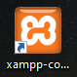

-When the program is finished installing double click on the icon of XAMPP on your desktop to start.

-When you start XAMPP just open its control panel, for localhost to work you need to launch 02 modules: Apache and MySQL by clicking their Start button as shown below. At this time, the Start button will change to the Stop button and the two modules will change to GREEN background.

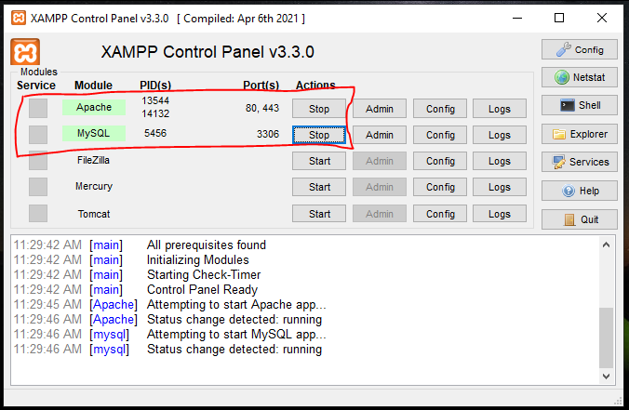

-To check, localhost is really working, enter the address below into a web browser, such as Chrome: [http://localhost/phpmyadmin/](http://localhost/phpmyadmin/%20) and <http://localhost/dashboard/>

If it leads to the phpMyAdmin page and the Dashboard page as shown below, congratulations, you have successfully installed localhost!

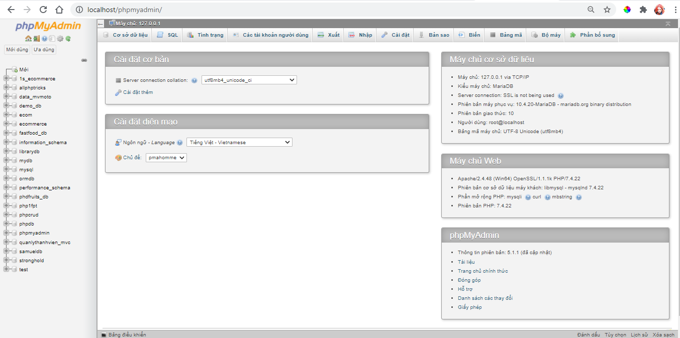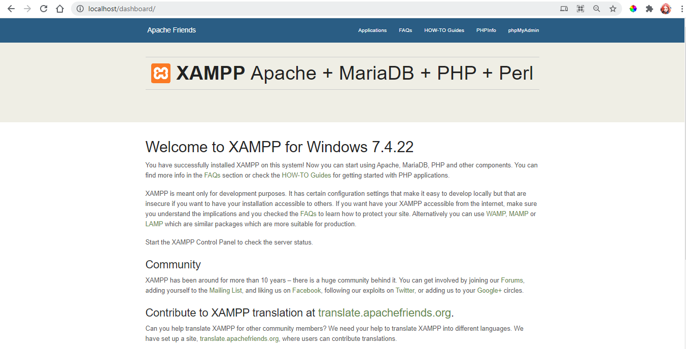

***Step 2: Copy files from CD to your desired hard disk***

- Download file eProject, access <https://bitly.com.vn/3qqcp1> or <https://github.com/apinkpanda1112/HARMONIC_Group2>

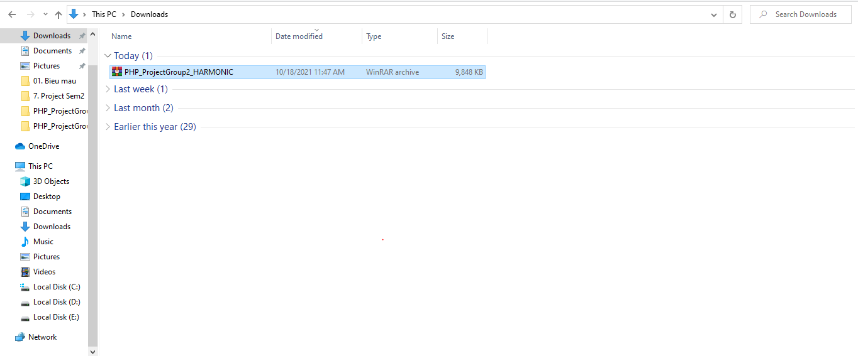- Open the rar file you just downloaded

- Right click on the file “.rar” and choose “Extract file”

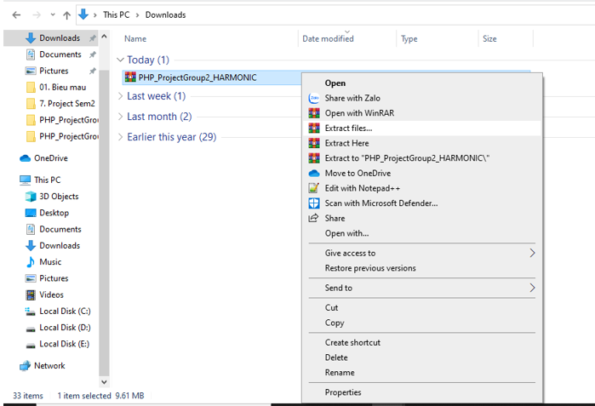

-Extract it and put it in Localdisk (the drive where you installed XAMPP).

[Here, my Localdisk is E, but I encourage everyone to install it in Localdisk(C). ]

-Localdisk (E)\xamapp\htdocs and click OK to Extract

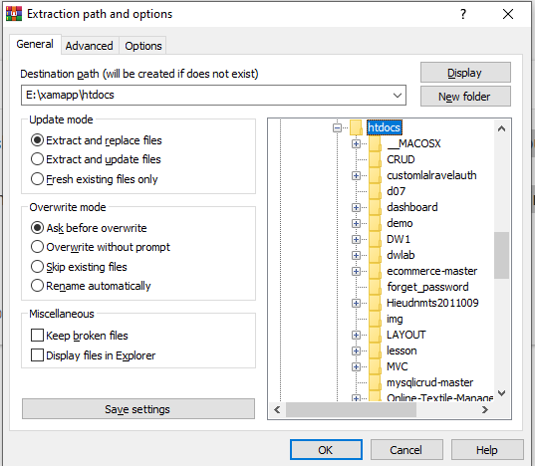

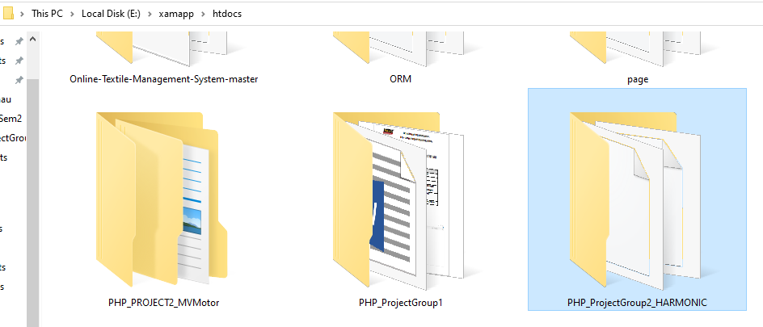-Extract completed you will get a file like this

***Step 3: Setup ecom database in MySQL***

-After enabling XAMPP (STEP 1), now open your web browser and enter localhost in the address bar: [http://localhost/phpmyadmin/](http://localhost/phpmyadmin/%20)

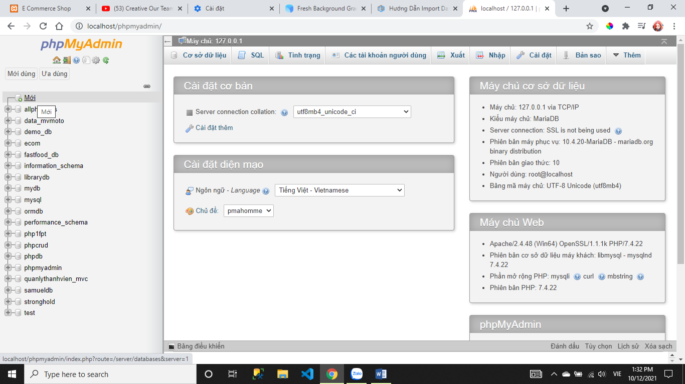- After typing it correctly and accessing, the phpmyadmin page will display like this, click on the words New(Mới) in the menu on the left.

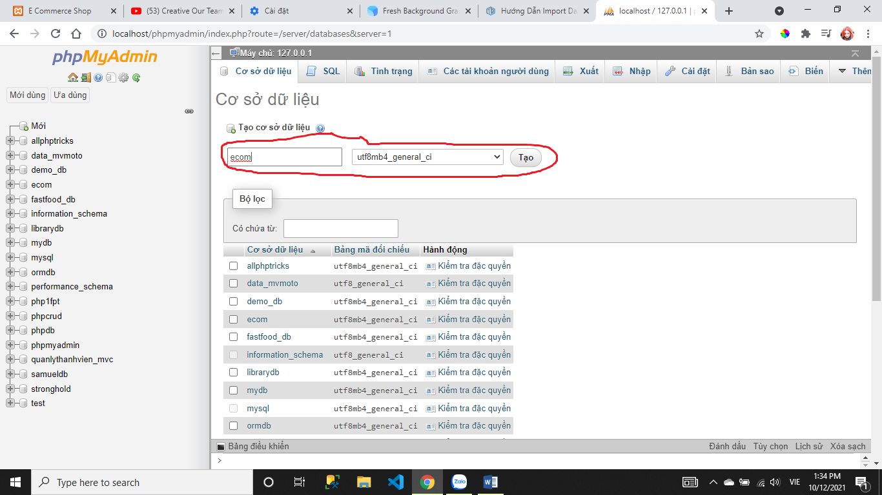- Next is to enter the name **ecom** to create the database, then select Clollection, I usually leave it as utf8mb4_general_ci then press Create (Tạo)

- The import page will appear, click Choose file (Chọn tệp), select the previously downloaded .sql file then scroll down and click Go(Thực hiện), wait a while your database will be imported.

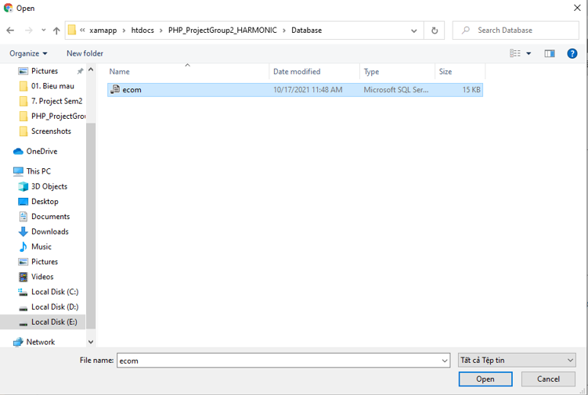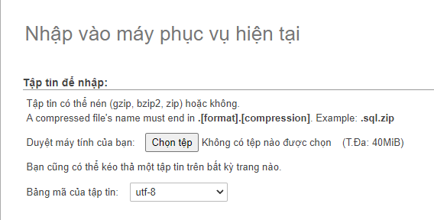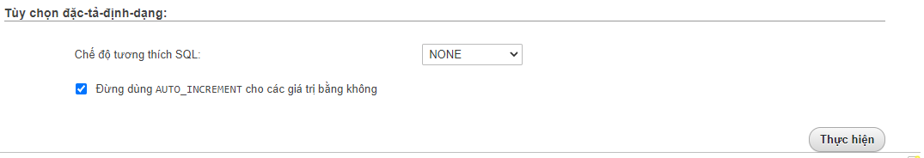

* Click on the **ecom** database to check whether all the tables are imported successfully.

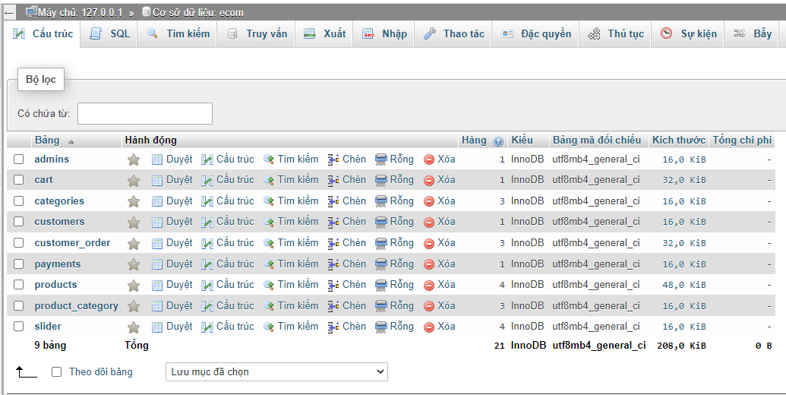

***STEP 4: Open project PHP_ProjectGroup2_HARMONIC***

* Open your browser, click on the following links to access the HARMONIC admin website and visitor website:

**+Visitor:** [http://localhost/PHP_ProjectGroup2_HARMONIC/](http://localhost/PHP_ProjectGroup2_HARMONIC/Developments)

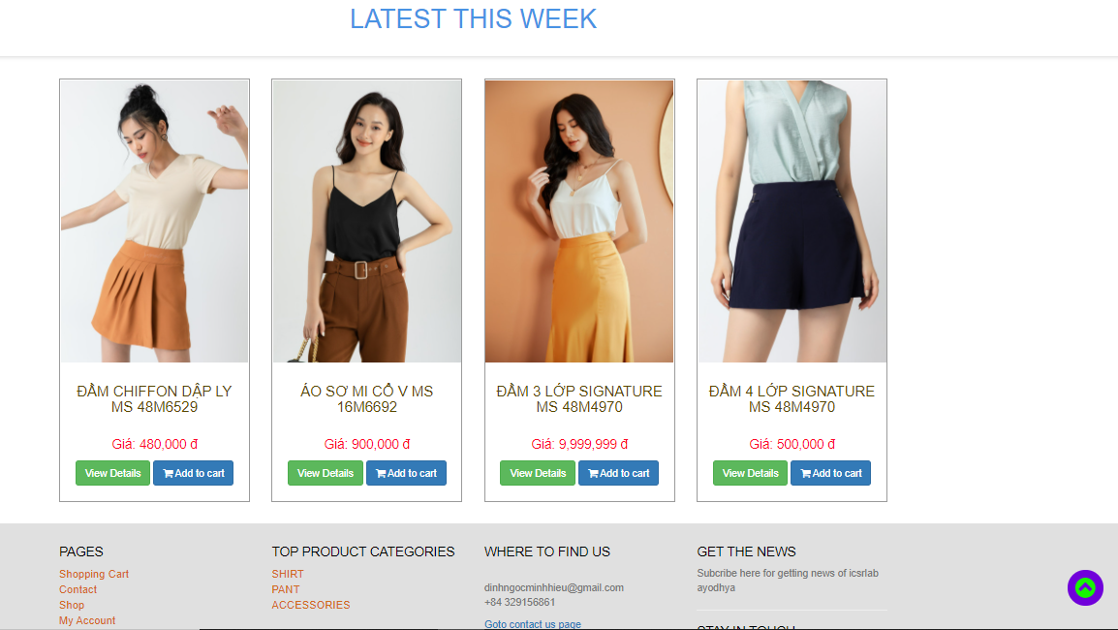

**+ Admin website**: [http://localhost/PHP_ProjectGroup2_HARMONIC/admin_area](http://localhost/PHP_ProjectGroup2_HARMONIC/Developments/admin_area)

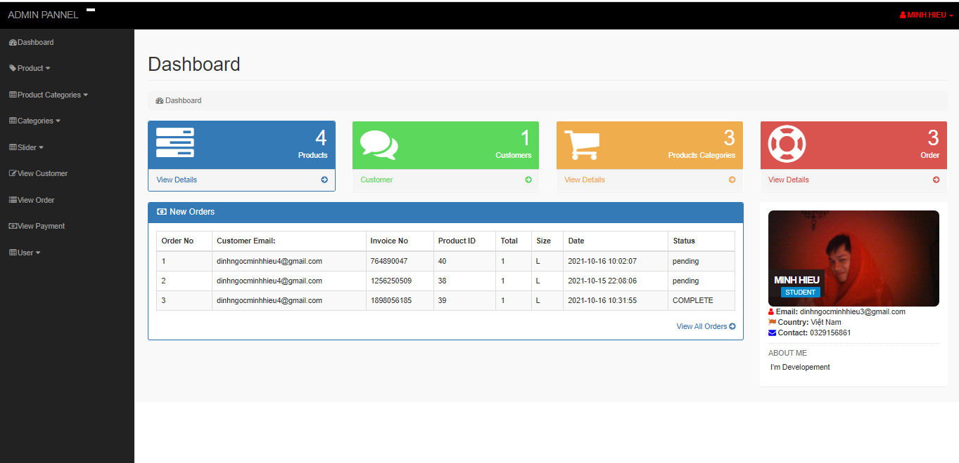

ATTENTION:

You may not know that on Xampp's Localhost, the default will be to use the network port Port is 80 (the reason is because when the user of this software types the domain name in the form http://localhost or 117.0.1.1 in the address bar). For web only, Xampp will use port 80 to read data on that Localhost.

How to change Port for XAMPP?

Here are 2 ways to change Port Xampp quite simply that I will guide you below (these are the ways used by quite a few people and also note that these are just 2 of the countless ways to change the Port for Xampp). Please XAMPP). With these 2 ways to change Port, you can use it to change to Port 8080 or 8888

Note: If you change the port to 8080 or 8888, when accessing the web, you must type the address http://localhost:8080 or http://localhost:8888 instead of http://localhost as usual.

HERE THE LINK TO CHANGE YOUR POST: <https://sinhvienshare.com/huong-dan-cach-doi-port-xampp/>